CSE 30 – Bitwise and Number Worksheet



1. Please convert decimal number 56 to 16-bit binary number. Then convert the binary number into a 16 bit hex number

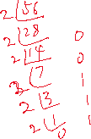

2. Convert 56 to the 2’s complement format (assume 16-bit word). Then convert the binary number into a 16 bit hex number



3. Convert -56 to the 2’s complement format (assume 16-bit word). Then convert the binary number into a 16 bit hex number

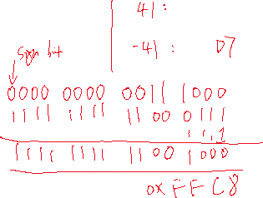

4. What is the value of x after we do the following operations

int x = 17;

x >>= 2



A. 3 B. 4 C. 17 D. None of the above



5. What is the value of z after we do the following operations

unsigned int x = 0x00000011, y = 0xFFFFFFF3;

unsigned int z = x ^ y;

A. 0xFFFFFFF1 B. 0x00000003 C. 0x11111113 D. None of the above

6. Write ARM instructions to check if bit 0 and 7 in r0 are both 1, if yes, assign r1 with 1, otherwise, assign r1 with 0. Bit 0 is on the right side of the number.

7. Find the value of the first 13 bits in r0 and assign to r1. Assume the value in r0 is unsigned.

e.g. r0 = 0101 1010 1111 1111 1111 0000 0000 0000

🡪 r1 will have 0000 0000 0000 0000 0000 1011 0101 1111

8. What will be printed out?



int x = 0x12345678;



char\* ptr = (char\*)(&x);



printf("%02x, %02x, %0x, %02x\n", \*ptr, \*(ptr+1), \*(ptr+2), \*(ptr+3));

